安装--elasticsearch
官方文档：https://www.elastic.co/guide/cn/elasticsearch/guide/current/index.html
yum -y install java
rpm --import https://packages.elastic.co/GPG-KEY-elasticsearch
vim /etc/yum.repos.d/elasticsearch.repo
[elasticsearch-2.x]
name=Elasticsearch repository for 2.x packages
baseurl=http://packages.elastic.co/elasticsearch/2.x/centos
gpgcheck=1
gpgkey=http://packages.elastic.co/GPG-KEY-elasticsearch
enabled=1
mkdir -p /data/es-data
chown elasticsearch:elasticsearch /data/es-data/
yum install -y elasticsearch
cd /etc/elasticsearch/
rpm -ql elasticsearch
vim elasticsearch.yml
[root@localhost /etc/elasticsearch]# grep "^[a-z]" elasticsearch.yml
cluster.name: myes
node.name: linux-node1
path.data: /data/es-data
path.logs: /var/log/elasticsearch
bootstrap.memory_lock: true
network.host: 10.10.10.25
http.port: 9200
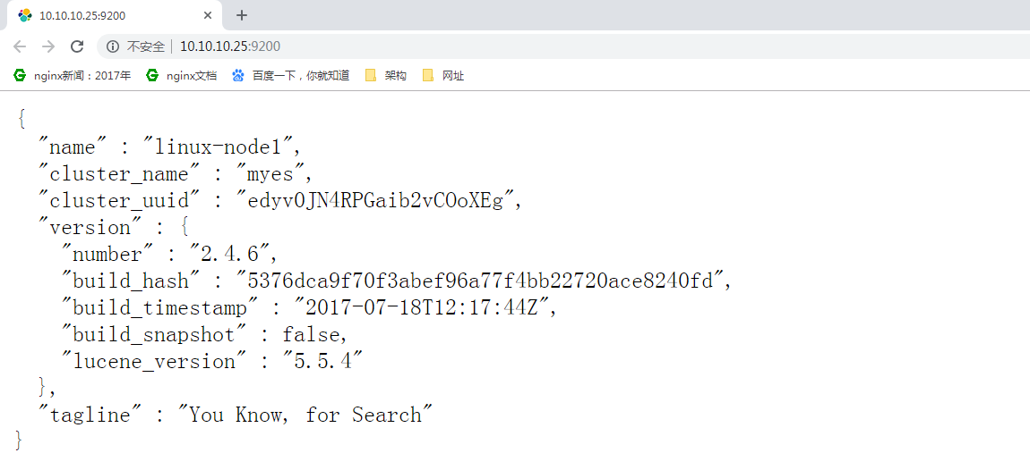
命令路径：/usr/share/elasticsearch/bin/plugin
插件路径：/usr/share/elasticsearch/plugins

安装 marvel-agent插件
/usr/share/elasticsearch/bin/plugin install marvel-agent

安装head插件
github地址：https://github.com/mobz/elasticsearch-head/
安装：/usr/share/elasticsearch/bin/plugin install mobz/elasticsearch-head
or：
wget https://github.com/mobz/elasticsearch-head/archive/master.zip

unzip master.zip
mv elasticsearch-head-master head
chown -R elasticsearch:elasticsearch /usr/share/elasticsearch/plugins
访问：http://10.10.10.25:9200/_plugin/head/
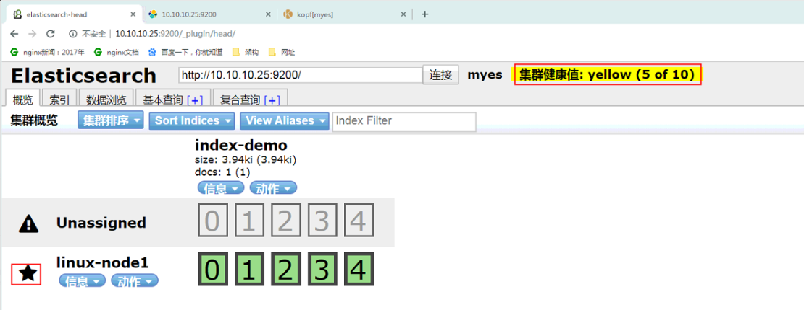
目前只有一个master节点：健康值为5/10

安装bigdesk 目前github支持elasticsearch的最高版本为1.30-1.3x
github地址：https://github.com/lukas-vlcek/bigdesk
安装方式： /usr/share/elasticsearch/bin/plugin install lukas-vlcek/bigdesk
安装kopf：
/usr/share/elasticsearch/bin/plugin install lmenezes/elasticsearch-kopf
or
wget https://github.com/lmenezes/elasticsearch-kopf/archive/master.zip
unzip master.zip
mv elasticsearch-kopf-master kopf

访问：http://10.10.10.25:9200/_plugin/kopf/
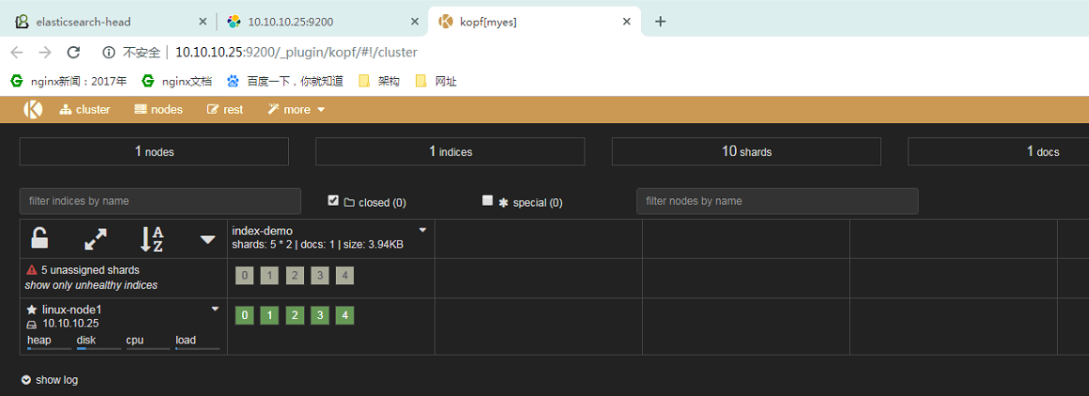

slave：安装===================================================================================================

[root@localhost /etc/elasticsearch]# grep "^[a-Z]" /etc/elasticsearch/elasticsearch.yml
cluster.name: myes
node.name: linux-node2
path.data: /data/es-data
path.logs: /var/log/elasticsearch
bootstrap.memory_lock: true
network.host: 10.10.10.26
http.port: 9200
discovery.zen.ping.unicast.hosts: ["10.10.10.25", "10.10.10.26"]
带实验：工作中是否要开启单播模（开启此参数，把IP加入，机器中只有一台加入即可），才能集群、
组播：
单播：
slave启动后对比单台效果：
如果很多的话，打开很慢，慢慢等就行了，木办法

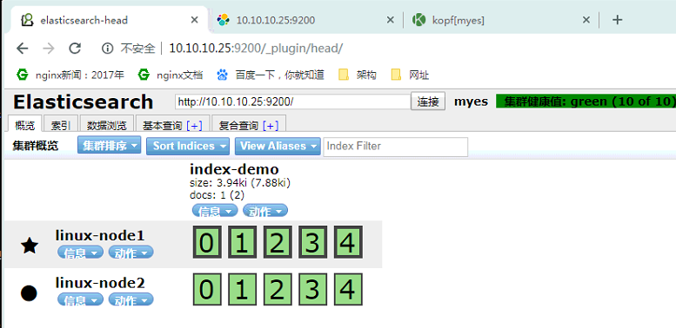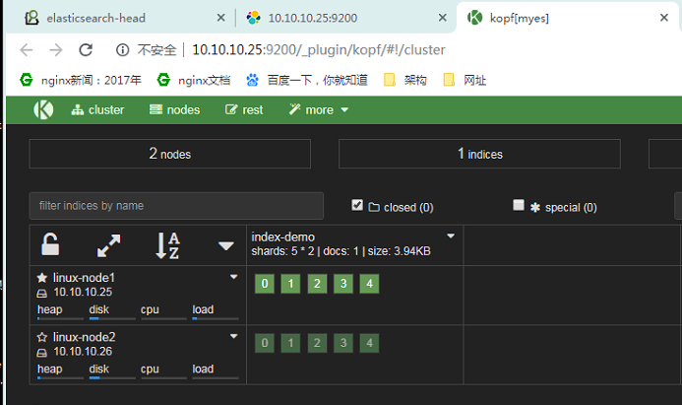

集群的状态：
curl -XGET "http://10.10.10.25:9200/_cluster/health?pretty=true"
官方帮助文档：https://www.elastic.co/guide/cn/elasticsearch/guide/current/index.html

安装--------logstash
官方文档：https://www.elastic.co/guide/en/logstash/current/index.html

rpm --import https://packages.elastic.co/GPG-KEY-elasticsearch
cat > /etc/yum.repos.d/logstash.repo <<EOF
[logstash-2.1]
name=Logstash repository for 2.1.x packages
baseurl=http://packages.elastic.co/logstash/2.1/centos
gpgcheck=1
gpgkey=http://packages.elastic.co/GPG-KEY-elasticsearch
enabled=1
EOF
yum install -y logstash

官方网站：https://www.elastic.co/guide/en/logstash/current/index.html

标准输入和输出：
/opt/logstash/bin/logstash -e 'input { stdin{} } output { stdout{} }'
使用rubydebug详细输出
/opt/logstash/bin/logstash -e 'input { stdin{} } output { stdout{ codec => rubydebug} }'
Settings: Default filter workers: 1
Logstash startup completed
hello word
{
"message" => "hello word",
"@version" => "1",
"@timestamp" => "2019-03-07T09:56:21.039Z",
"host" => "localhost.localdomain"
}
错误：
[root@localhost ~]# /opt/logstash/bin/logstash -e 'input { stdin{} } output { stdout{} }'
OpenJDK 64-Bit Server VM warning: If the number of processors is expected to increase from one, then you should configure the number of parallel GC threads appropriately using -XX:ParallelGCThreads=N
Settings: Default filter workers: 1
Logstash startup completed
解决：修改虚拟机cpu数量即可
写入数据到elasticsearch
简单点写： /opt/logstash/bin/logstash -e 'input { stdin{} } output { elasticsearch { hosts => ["10.10.10.25:9200"]} }'

/opt/logstash/bin/logstash -e 'input { stdin{} } output { elasticsearch { hosts => ["10.10.10.25:9200"] index => "logstash-%{+YYYY.MM.dd}" } }'
Settings: Default filter workers: 1
Logstash startup completed
heh
hah
hh
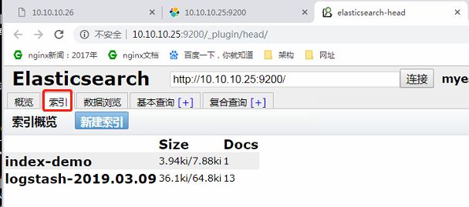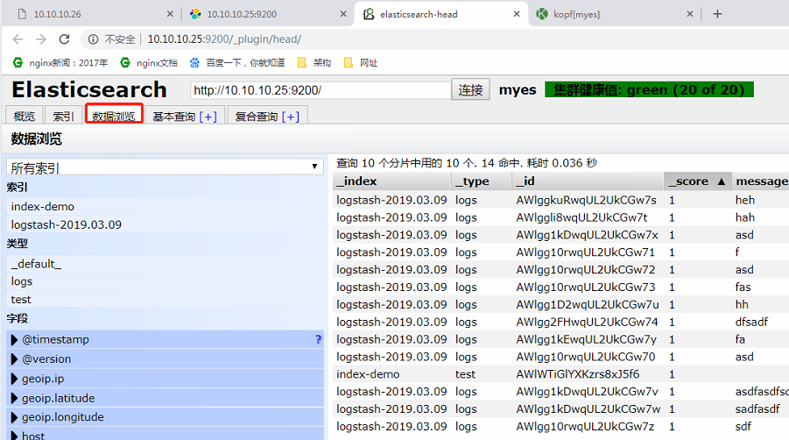

既标准输出到屏幕、同时写入到elasticsearch：
/opt/logstash/bin/logstash -e 'input { stdin{} } output { elasticsearch { hosts => ["10.10.10.25:9200"]} stdout{ codec => rubydebug}}'

/opt/logstash/bin/logstash -e 'input { stdin{} } output { stdout {codec =>rubydebug } elasticsearch { hosts => ["10.10.10.25:9200"] index => "logstash-%{+YYYY.MM.dd}" } }'
Settings: Default filter workers: 1
Logstash startup completed
111111111111111111111111
{
"message" => "111111111111111111111111",
"@version" => "1",
"@timestamp" => "2019-03-09T03:42:44.650Z",
"host" => "nginx"

logstash的配置和文件的编写：

根据启动脚本：cat /etc/init.d/logstash LS_CONF_DIR=/etc/logstash/conf.d 配置写到此目录下（可以修改）
官方文档：
https://www.elastic.co/guide/en/logstash/current/plugins-inputs-file.html#plugins-inputs-file-path
https://www.elastic.co/guide/en/logstash/current/configuration-file-structure.html
https://www.elastic.co/guide/en/logstash/current/event-dependent-configuration.html
output插件：
https://www.elastic.co/guide/en/logstash/current/output-plugins.html

/opt/logstash/bin/logstash -f -t /etc/logstash/conf.d/file2.conf -t 测试配置文件是否正确

sincdb ：大约意思 logstash读取日志的记录点
sincedb_path：可以设置一个路径 默认 /root or /var/lib/logstash/ 貌似都有，用到再说吧

start_position => "beginning" "end"

[root@nginx ~]# cat /var/lib/logstash/.sincedb_
.sincedb_1fb922e15ccea4ac0d028d33639ba3ea .sincedb_a9b9fed7edff6fd888ffe131a05b5397
.sincedb_452905a167cf4509fd08acb964fdb20c .sincedb_d883144359d3b4f516b37dba51fab2a2

1、必须包含input和outpu
2、input codec filter output
测试一、标准输出 与 写入elasticsearch
[root@nginx conf.d]# cat demo.conf
input {
stdin {}
}
#input{stdin{}}
output {
elasticsearch
{
hosts => ["10.10.10.25:9200"]
index => "logstash-%{+YYYY.MM.dd}"
}
stdout
{
codec => rubydebug
}
}
[root@nginx conf.d]# /opt/logstash/bin/logstash -f /etc/logstash/conf.d/demo.conf
Settings: Default filter workers: 1
Logstash startup completed
test
{
"message" => "test",
"@version" => "1",
"@timestamp" => "2019-03-09T06:26:25.679Z",
"host" => "nginx"
}

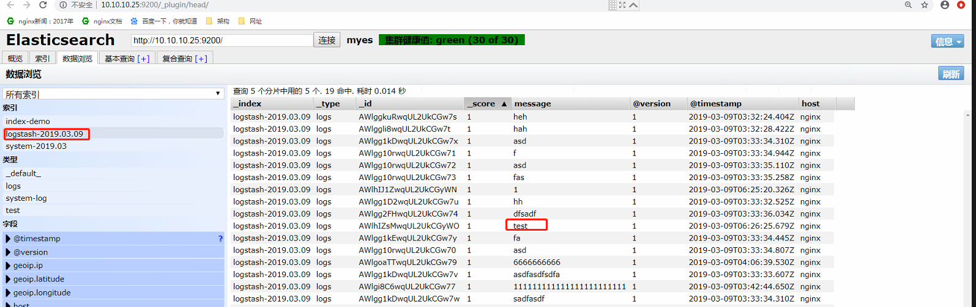

测试二、写入到elasticsearch：
[root@nginx conf.d]# cat file.conf
input{
file{
path => ["/var/log/messages","/var/log/secure" ]
type => "system-log"
start_position => "beginning"
}
}
filter{
}
output {
elasticsearch
{
hosts => ["10.10.10.25:9200"]
index => "system-%{+YYYY.MM}"
}
}
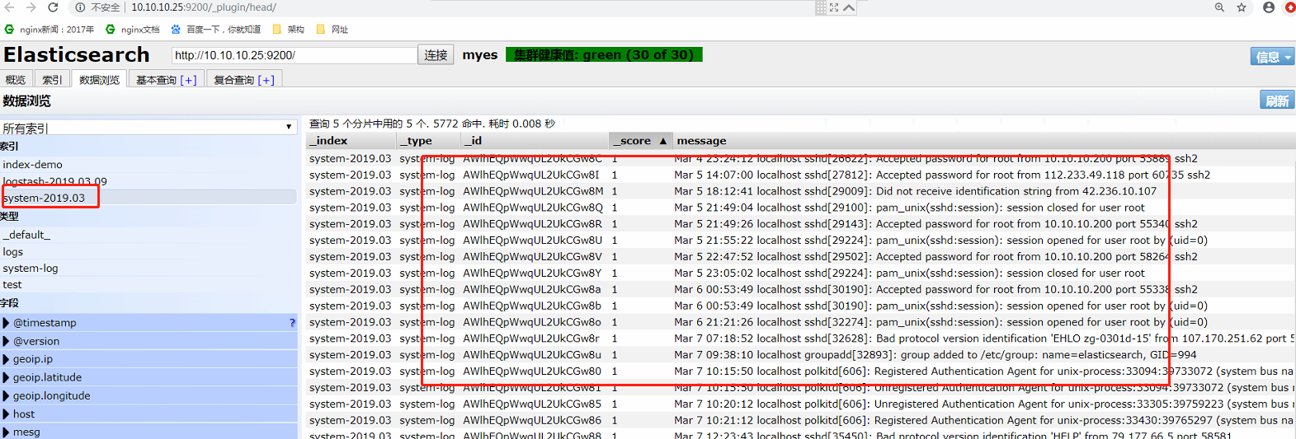
测试三、写入到elasticsearch：

注意：
如果你的日志中有type字段 那你就不能在conf文件中使用type

[root@nginx conf.d]# cat file1.conf
input {
file {
path => "/var/log/messages"
type => "messages"
start_position => "beginning"
}
}

input {
file {
path => "/var/log/elasticsearch/myes.log"
type => "es-error"
start_position => "beginning"
}
}
output {

if [type] == "messages"{
elasticsearch {
hosts => ["10.10.10.25:9200"]
index => "system-messages-%{+YYYY.MM.dd}"
}
}

if [type] == "es-error"{
elasticsearch {
hosts => ["10.10.10.25:9200"]
index => "es-error-%{+YYYY.MM.dd}"
}
}
}
暂停一段落：
收集TCP日志：
https://www.elastic.co/guide/en/logstash/current/plugins-inputs-tcp.html
使用nc发送数据：
25端logstash配置：
[root@nginx conf.d]# cat vim tcp.conf
input{
tcp{
type => "tcp"
port => "6666"
mode => "server"
}
}

output{
stdout{
codec => "rubydebug"
}
}
IP26写入数据 25即可收到
echo "hehe" |nc 10.10.10.25 6666
nc 10.10.10.25 6666 < /etc/hostname
echo "hehehehehe" >/dev/tcp/10.10.10.25/6666

Filter plugins
使用filter 的grok 插件 对收集的事件，进行过滤，字段拆分等
https://www.elastic.co/guide/en/logstash/current/plugins-filters-grok.html
例如：收集apaceh日志
使用说明：/opt/logstash/vendor/bundle/jruby/1.9/gems/logstash-patterns-core-2.0.2/patterns
[root@elk-node1 ~]# cat grok.conf
input {
stdin{}
}
filter {
grok {
match => { "message" => "%{IP:client} %{WORD:method} %{URIPATHPARAM:request} %{NUMBER:bytes} %{NUMBER:duration}" }
}4
}
output {
stdout{
codec => "rubydebug"
}
}

执行检测：
[root@elk-node1 ~]# /opt/logstash/bin/logstash -f grok.conf
Settings: Default filter workers: 1
Logstash startup completed
55.3.244.1 GET /index.html 15824 0.043 #输入这个，下面就会自动形成字典的形式
{
"message" => "55.3.244.1 GET /index.html 15824 0.043",
"@version" => "1",
"@timestamp" => "2019-0113T11:45:47.882Z",
"host" => "elk-node1",
"client" => "55.3.244.1",
"method" => "GET",
"request" => "/index.html",
"bytes" => "15824",
"duration" => "0.043"
}

ELK中使用redis作为中间件，缓存日志采集内容

如果使用redis作为ELKstack消息队列，需要对所有的list key的长度进行监控

根据实际情况：例如超过10万报警

Kibanna安装与使用
使用手册：https://www.elastic.co/guide/cn/kibana/current/index.html
版本查看：https://www.elastic.co/downloads/past-releases
安装：https://www.elastic.co/guide/cn/kibana/current/rpm.html
rpm --import https://artifacts.elastic.co/GPG-KEY-elasticsearch
cat > /etc/yum.repos.d/kibana.repo <<EOF
[kibana-6.x]
name=Kibana repository for 6.x packages
baseurl=https://artifacts.elastic.co/packages/6.x/yum
gpgcheck=1
gpgkey=https://artifacts.elastic.co/GPG-KEY-elasticsearch
enabled=1
autorefresh=1
type=rpm-md
EOF
说明一下：想安装5.x把上面的6改为5即可
由于elasticsearch安装的为2.X 我擦的用kibana5x不行的。
4.5.4版本安装配置源如下
cat > /etc/yum.repos.d/kibana.repo <<EOF
[kibana-4.5]
name=Kibana repository for4.5.x packages
baseurl=http://packages.elastic.co/kibana/4.5/centos
gpgcheck=1
gpgkey=http://packages.elastic.co/GPG-KEY-elasticsearch
enabled=1
EOF
yum -y install kibana
[root@nginx conf.d]# grep "^[a-Z]" /etc/kibana/kibana.yml
server.port: 5601
server.host: "10.10.10.25"
elasticsearch.url: "http://10.10.10.26:9200"
kibana.index: ".kibana"
http://10.10.10.25:5601/

如下摘自https://www.cnblogs.com/kevingrace/p/5919021.html
暂未学习
==============logstash配置java环境===============
由于新版的ELK环境要求java1.8，但是有些服务器由于业务代码自身限制只能用java6或java7。
这种情况下，要安装Logstash，就只能单独配置Logstas自己使用的java环境了。
操作如下：
0) 使用rpm包安装logstash

1）安装java8，参考：http://www.cnblogs.com/kevingrace/p/7607442.html

2）在/etc/sysconfig/logstash文件结尾添加下面两行内容：
[root@cx-app01 ~]# vim /etc/sysconfig/logstash
.......
JAVA_CMD=/usr/local/jdk1.8.0_172/bin
JAVA_HOME=/usr/local/jdk1.8.0_172

3）在/opt/logstash/bin/logstash.lib.sh文件添加下面一行内容：
[root@cx-app02 ~]# vim /opt/logstash/bin/logstash.lib.sh
.......
export JAVA_HOME=/usr/local/jdk1.8.0_172

4) 然后使用logstash收集日志，就不会报java环境错误了。
==================配置范例===================
如下的配置范例：
192.168.10.44为elk的master节点，同时也是redis节点

[root@client-node01 opt]# pwd
/opt
[root@client-node01 opt]# cat redis-in.conf
input {
file {
path => "/usr/local/tomcat8/logs/catalina.out"
type => "tomcat8-logs"
start_position => "beginning"
codec => multiline {
pattern => "^\[" //表示收集以"["开头的日志信息
negate => true
what => "previous"
}
}
}

output {
if [type] == "tomcat8-logs"{
redis {
host => "192.168.10.44"
port => "6379"
db => "1"
data_type => "list"
key => "tomcat8-logs"
}
}
}

[root@client-node01 opt]# cat redis-input.conf
input {
file {
path => "/var/log/messages"
type => "systemlog"
start_position => "beginning"
stat_interval => "2"
}
}

output {
if [type] == "systemlog" {
redis {
data_type => "list"
host => "192.168.10.44"
db => "2"
port => "6379"
key => "systemlog"
}
}

}
[root@client-node01 opt]# cat file.conf
input {
redis {
type => "tomcat8-logs"
host => "192.168.10.44"
port => "6379"
db => "1"
data_type => "list"
key => "tomcat8-logs"
}

redis {
type => "systemlog"
host => "192.168.10.44"
port => "6379"
db => "2"
data_type => "list"
key => "systemlog"
}

}

output {

if [type] == "tomcat8-logs"{
elasticsearch {
hosts => ["192.168.10.44:9200"]
index => "elk-node2-tomcat8-logs-%{+YYYY.MM.dd}"
}
}

if [type] == "systemlog"{
elasticsearch {
hosts => ["192.168.10.44:9200"]
index => "elk-node2-systemlog-%{+YYYY.MM.dd}"
}
}
}
[root@client-node01 opt]# /opt/logstash/bin/logstash -f /opt/redis-in.conf --configtest
Configuration OK
[root@client-node01 opt]# /opt/logstash/bin/logstash -f /opt/redis-input.conf --configtest
Configuration OK
[root@client-node01 opt]# /opt/logstash/bin/logstash -f /opt/file.conf --configtest
Configuration OK

启动logstash
[root@client-node01 opt]# /opt/logstash/bin/logstash -f /opt/redis-in.conf &
[root@client-node01 opt]# /opt/logstash/bin/logstash -f /opt/redis-input.conf &
[root@client-node01 opt]# /opt/logstash/bin/logstash -f /opt/file.conf &

这时候，当/usr/local/tomcat8/logs/catalina.out和/var/log/messages文件里有新日志信息写入时，就会触发动作，
在redis里就能查看到相关信息，并查看写入到es里。

=========================================================================================================
温馨提示：
当客户机的日志信息收集后，经过redis刚读到es数据库里后，如果没有新数据写入，则默认在es的访问界面里是看不到
数据的，只有当日志文件里有新的日志写入后才会触发数据展示的动作，即es的访问界面（http://192.168.10.44:9200/_plugin/head/）
里才能看到日志数据的展示效果。
==========================================================================================================

假设想上面两个文件里写入测试数据
[root@client-node01 opt]# echo "hellohellohellohello" >> /var/log/messages
[root@client-node01 opt]# echo "[hahahahahahhahahahahahahahahahahahah]" >> /usr/local/tomcat8/logs/catalina.out

到redis里发现有相关的key，很快就会读到es里。可以配置到kibana里观察。

可以先测试下日志信息是否写到redis里？然后再测试下数据是否从redis读到es里？一步步确定数据去向。

注意上面redis-in.conf文件中的下面设置，使用正则匹配，收集以哪些字符开头的日志信息：
pattern => "^\[" 表示收集以"["开头的日志信息
pattern => "^2018" 表示收集以"2018"开头的日志信息
pattern => "^[a-zA-Z0-9]" 表示收集以字母（大小写）或数字开头的日志信息
pattern => "^[a-zA-Z0-9]|[^ ]+" 表示收集以字母（大小写）或数字或空格的日志信息

