扩展测压工具：



ab webbench（web半吃） loadrunner（漏的ruang呢）Jmeter（鸡米特）

**错误扩展动态链接库：**

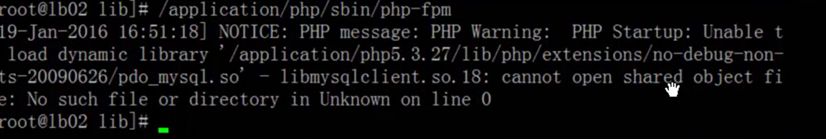

vim /etc/ld.so.conf.d/local.conf

增加一行：/usr/lib64

ldconfig

或者查找so文件，

创建ln -s /查找到的so路径/***.so /usr/lib64/***.so

**常见错误：---查询区**

编译PHP时报错：  
...................

........................  
checking for fabsf... yes  
checking for floorf... yes  
configure: error: libjpeg.(a|so) not found.  
解决：  
[root@goolen php-5.3.6]# ls /usr/lib64/libjpeg.so  
/usr/lib64/libjpeg.so  
[root@goolen php-5.3.6]# ln -s /usr/lib64/libjpeg.so /usr/lib/libjpeg.so  
  
重新编译报另外一个错：  
configure: error: libpng.(a|so) not found.  
  
解决：  
[root@goolen php-5.3.6]# ln -s /usr/lib64/libpng.so /usr/lib/libpng.so  
  
重新编译报错：  
checking for location of ICU headers and libraries... not found  
configure: error: Unable to detect ICU prefix or no failed. Please verify ICU install prefix and make sure icu-config works.  
  
解决：  
[root@goolen php-5.3.6]# yum install -y libicu-devel  
Loaded plugins: product-id, security, subscription-manager  
Updating certificate-based repositories.  
Unable to read consumer identity  
Setting up Install Process  
Nothing to do  
  
[root@goolen goolen]# ls libicu-devel-4.2.1-9.1.el6_2.x86_64.rpm   
libicu-devel-4.2.1-9.1.el6_2.x86_64.rpm  
  
[root@goolen goolen]# rpm -ivh libicu-devel-4.2.1-9.1.el6_2.x86_64.rpm   
warning: libicu-devel-4.2.1-9.1.el6_2.x86_64.rpm: Header V4 RSA/SHA1 Signature, key ID c105b9de: NOKEY  
Preparing...                ########################################### [100%]  
   1:libicu-devel           ########################################### [100%]  
  
编译报错：  
configure: error: mcrypt.h not found. Please reinstall libmcrypt.  
  
解决：  
[root@goolen goolen]# rpm -ivh libmcrypt-2.5.8-119.1.x86_64.rpm   
warning: libmcrypt-2.5.8-119.1.x86_64.rpm: Header V3 RSA/SHA256 Signature, key ID 3dbdc284: NOKEY  
error: Failed dependencies:  
        libc.so.6(GLIBC_2.14)(64bit) is needed by libmcrypt-2.5.8-119.1.x86_64  
[root@goolen goolen]# yum install -y glibc  
Loaded plugins: product-id, security, subscription-manager  
Updating certificate-based repositories.  
Unable to read consumer identity  
Setting up Install Process  
Package glibc-2.12-1.80.el6.x86_64 already installed and latest version  
Nothing to do  
[root@goolen goolen]# rpm -ivh libmcrypt-2.5.8-119.1.x86_64.rpm --force  
warning: libmcrypt-2.5.8-119.1.x86_64.rpm: Header V3 RSA/SHA256 Signature, key ID 3dbdc284: NOKEY  
error: Failed dependencies:  
        libc.so.6(GLIBC_2.14)(64bit) is needed by libmcrypt-2.5.8-119.1.x86_64  
[root@goolen goolen]# rpm -ivh libmcrypt-2.5.8-119.1.x86_64.rpm --force --nodeps  
warning: libmcrypt-2.5.8-119.1.x86_64.rpm: Header V3 RSA/SHA256 Signature, key ID 3dbdc284: NOKEY  
Preparing...                ########################################### [100%]  
   1:libmcrypt              ########################################### [100%]  
  
[root@goolen goolen]# rpm -ivh libmcrypt-devel-2.5.8-119.1.x86_64.rpm   
warning: libmcrypt-devel-2.5.8-119.1.x86_64.rpm: Header V3 RSA/SHA256 Signature, key ID 3dbdc284: NOKEY  
Preparing...                ########################################### [100%]  
   1:libmcrypt-devel        ########################################### [100%]  
  
重新编译报错：  
checking for libmcrypt version... >= 2.5.6  
checking for mcrypt_module_open in -lmcrypt... no  
checking for mcrypt_module_open in -lmcrypt... no  
configure: error: Sorry, I was not able to diagnose which libmcrypt version you have installed.  
  
解决：卸载2.5.8版本，换2.5.7版本  
[root@goolen goolen]# rpm -e libmcrypt  
error: Failed dependencies:  
        libmcrypt = 2.5.8 is needed by (installed) libmcrypt-devel-2.5.8-119.1.x86_64  
[root@goolen goolen]# rpm -e libmcrypt libmcrypt-devel  
  
[root@goolen goolen]# rpm -ivh libmcrypt-2.5.7-5.el5.x86_64.rpm libmcrypt-devel-2.5.7-5.el4.x86_64.rpm --nodeps  
warning: libmcrypt-2.5.7-5.el5.x86_64.rpm: Header V3 DSA/SHA1 Signature, key ID 217521f6: NOKEY  
Preparing...                ########################################### [100%]  
   1:libmcrypt-devel        ########################################### [ 50%]  
   2:libmcrypt              ########################################### [100%]

[root@web02 php-5.3.29]# diff php.ini-*

php.ini-development php.ini-production

开发环境和生成环境

开发环境把错误打开，生成环境把错误关闭

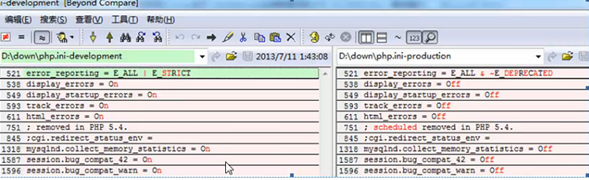

php-fpm

